**Docker Part 1 Assignment – 2**

1. Save the image created in assignment 1 as a Docker image

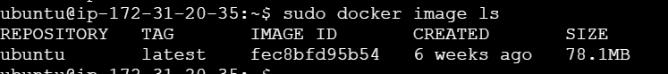

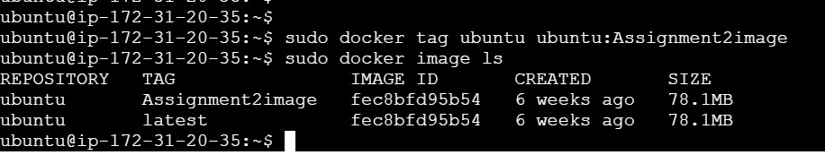

1. Launch container from this new image and map the port to 81



1. Go inside the container and start the Apache2 service

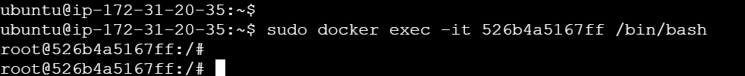

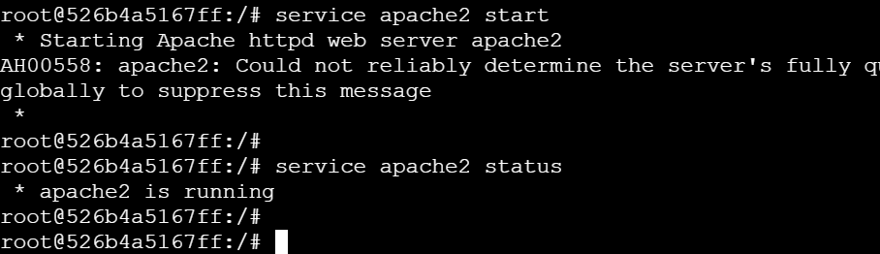

1. Check if you are able to access it on the browser

